Dear Client,
This guide will help you better understand how to earn continuing education contact hours for AACN’s Basic ECG Interpretation. The steps and screenshots in this guide take you through the entire CE process—from the Lesson Information Page in the MCS LMS to the AACN CE Test Center where you can access your CE Certificate.
Important Note: AACN’s Basic ECG Interpretation course is a single module with seven (7) lessons imbedded within the module.
This guide is divided into the following steps:
- Steps to Earn Contact Hours for this CE Activity
- Steps to Open and Print Your Certificate

Steps to Earn Contact Hours for this CE Activity
- From ‘My E-learning Lessons page’, click the E-learning By Module tab.
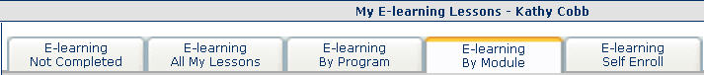

- From “Lessons in Module: AACN: ECG Basic Interpretation”, click the course title, AACN: Basic ECG Interpretation.
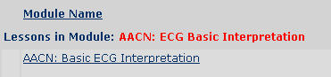
Your ‘Lesson Information’ screen opens.
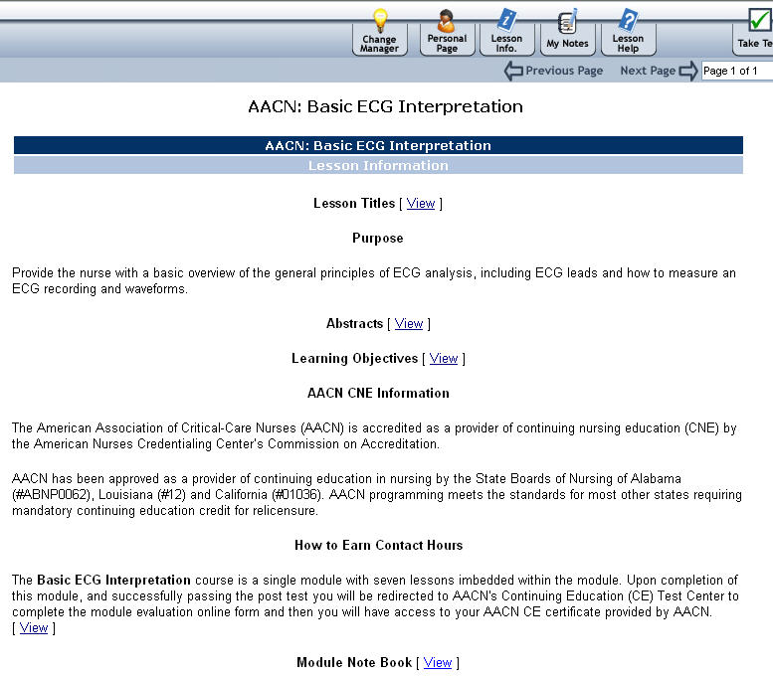

- Click the Next Page link in the upper right.

- An introduction screen opens. Click the Take this course link (bottom of the screen).
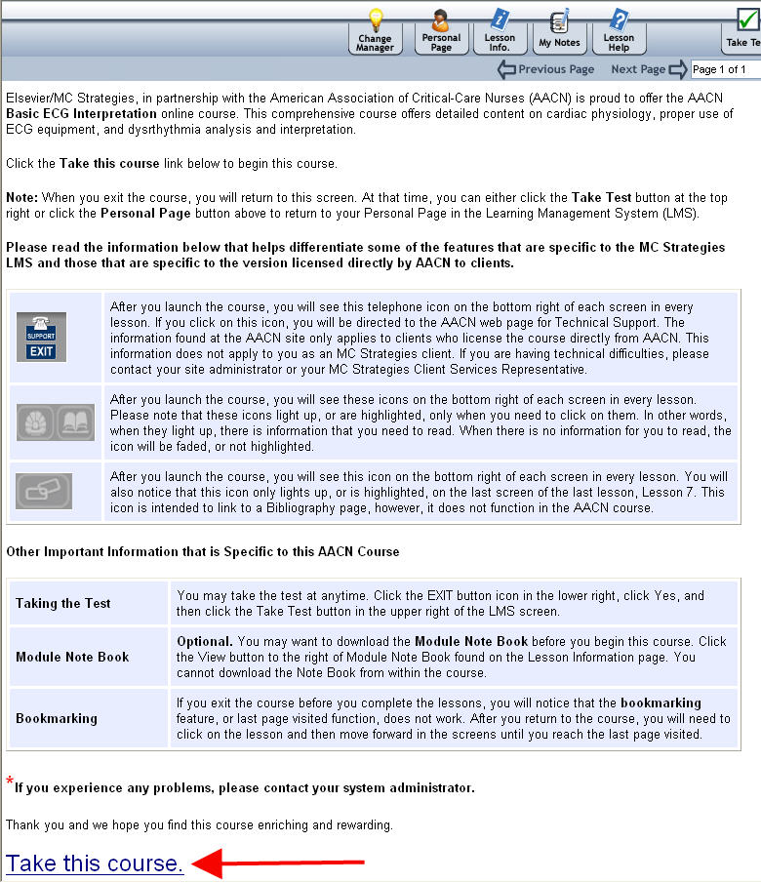
- The course opens in a new window.
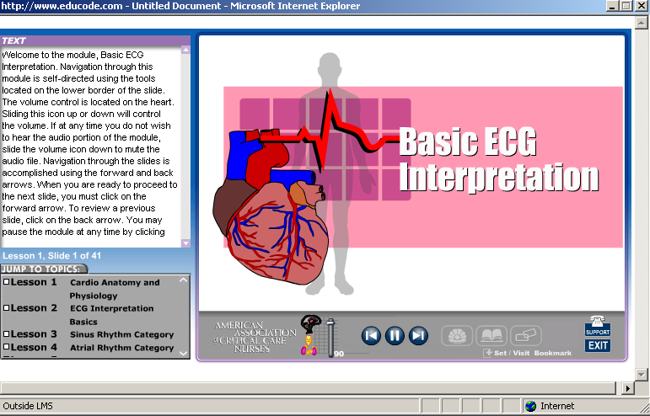

- When you complete all seven (7) lessons, you see the screen below. Click Exit (in the lower right) to close the course.
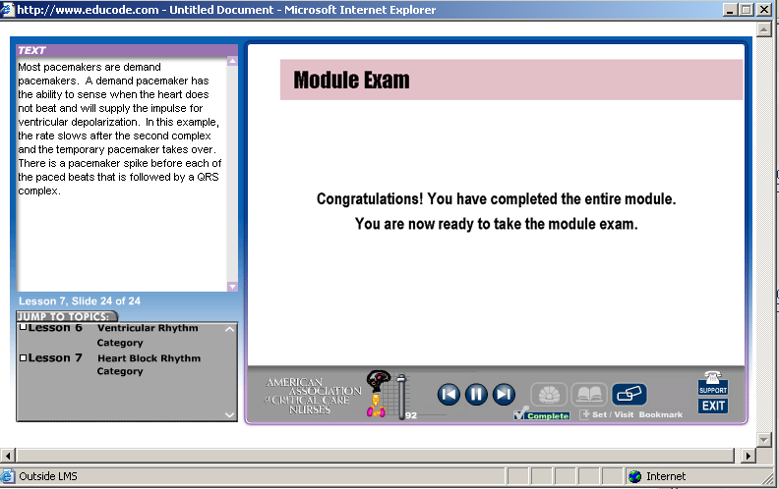
- Click Yes from the popup.
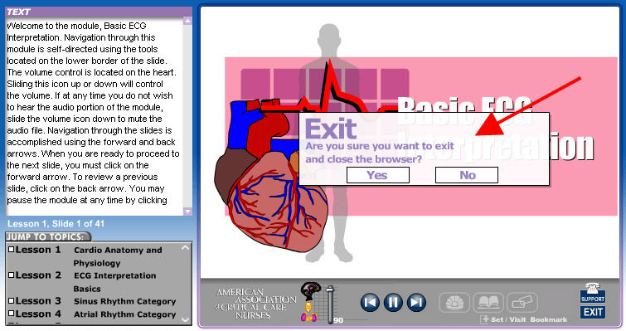

- You return back to the introduction screen. Click Personal Page.
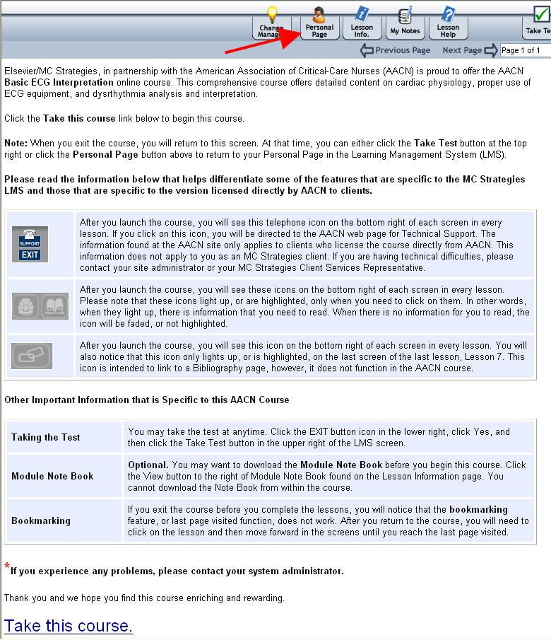

- You return to your Personal Page – ‘My E-learning Lessons’. Click the Test button to begin the posttest.
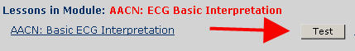
The screen below opens and includes important information about the Test (e.g., number of questions on the test).
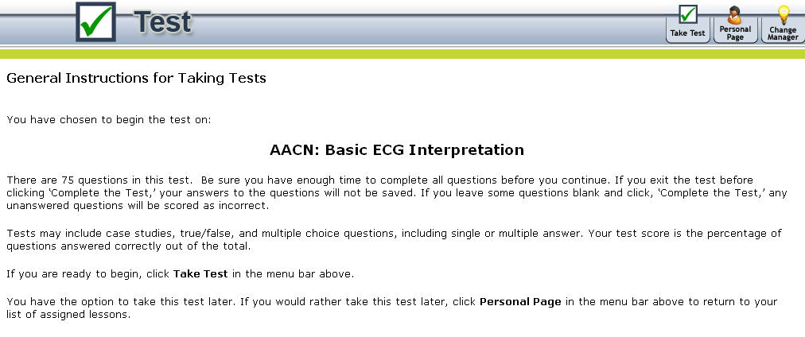
Note: To earn the contact hours, you must achieve a score of 80% or greater. You may complete the course and take the Test as many times as necessary to achieve a passing score; however, you can receive contact hour credit only once - the first time you achieve the passing score.
- After you complete the Test, click the Personal Page button in the upper right.
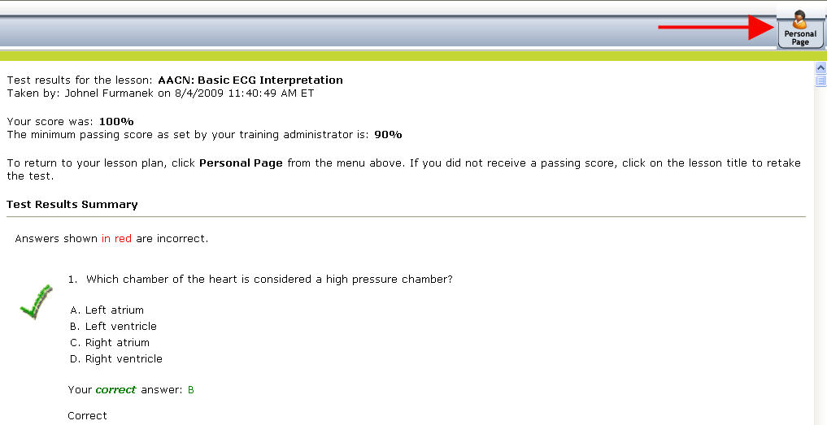

Steps to Open and Print Your Certificate
- Click the Reports button - E-learning Credits Earned. The lesson’s title is on the left; and on the right is the ‘Hours’ column.
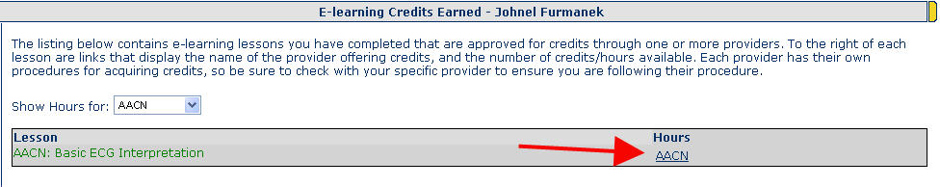

- Click AACN.
Note: The “AACN CE Test Center” opens. Notice that beneath the course title, these words appear: “This test is FREE to both member and nonmember CE customers.” You will not be taking a test. The word “test” here is referring to the module evaluation.

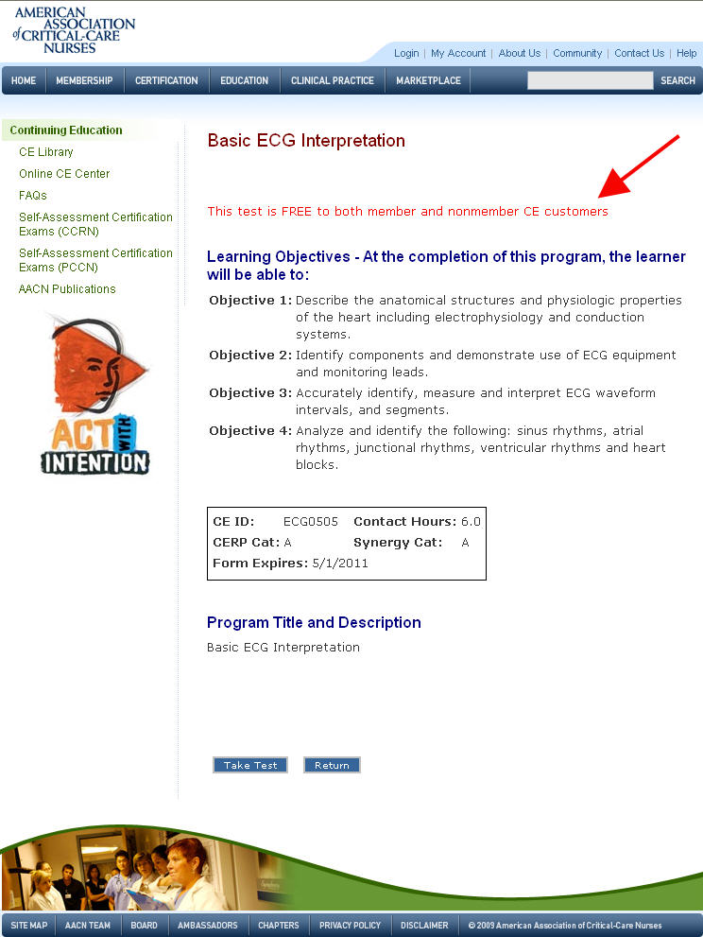
- At the bottom of the page of the AACN CE Test Center, click the “Take Test” button. Again, this is not a test.
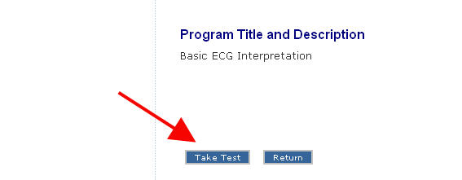

- Answer the questions and click Submit.
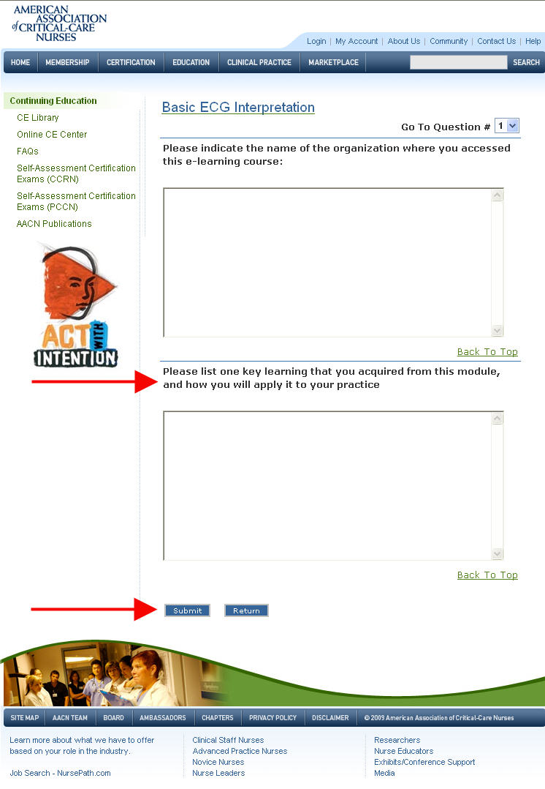

- Complete the module evaluation online form and then click the Submit button at the bottom of the page.
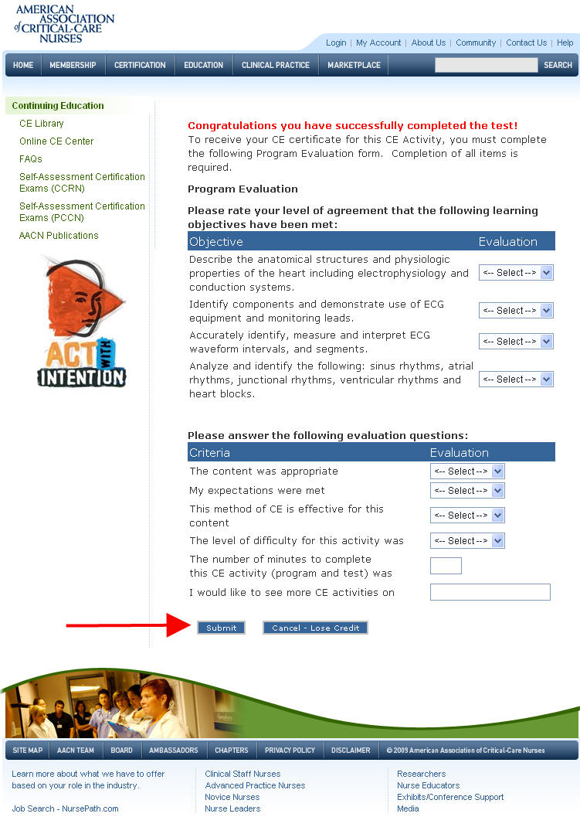

- Logon to the AACN CE Test Center to gain access to your AACN CE certificate.
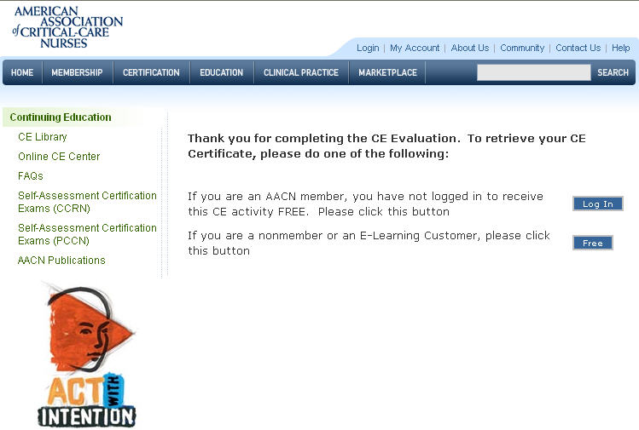

- Click on Certificate to access and print your CE Certificate.


