FTP Instructions for Internet Explorer 7

Table of Contents
FTP Minimum Requirements 2
Access an FTP site from IE 7 3

FTP Minimum Requirements
- Client must have the ability to disable “Passive” FTP.
- Client must have PORT 21 Open on their firewall. If they do not, they will need to request it to be opened by their Network Administrator.
- Client must have FTP privileges on their computer login. If they do not, they will need to request permissions to be added to their login by their IT administrators.
- Internet Explorer is an acceptable FTP client, but Elsevier cannot offer advanced troubleshooting outside of the instructions contained in this document.
- Elsevier recommends using a 3rd Party FTP client such as FileZilla for more reliable file transfers.
Note: For more information and help with Filezilla, go to: http://filezilla-project.org/

Access an FTP site from IE 7
- Open Internet Explorer.
- Click the Tools menu.
- Select the Internet Options menu option.
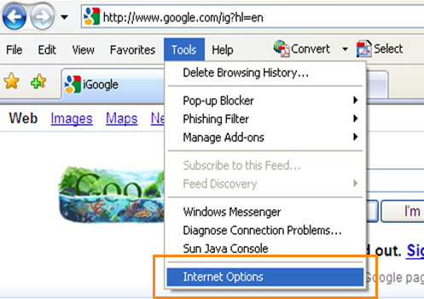
- Click the Advanced tab in the pop-up window.
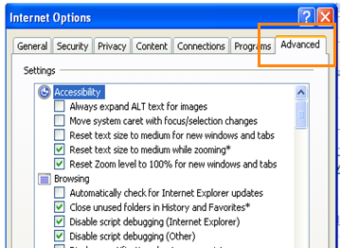
- Under Browsing, verify the checkbox “Enable FTP folder view (outside of Internet Explorer)” is enabled.
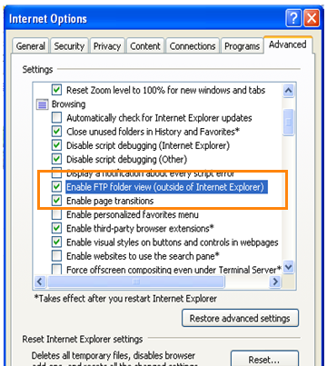
- Under Browsing, verify the checkbox “Use Passive FTP (for firewall and DSL modem compatibility)” is disabled.
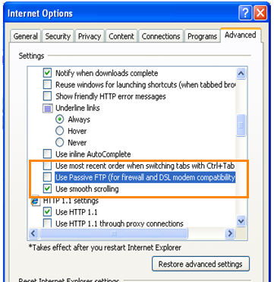
- Click the [Apply] button.
- Click the [OK] button.
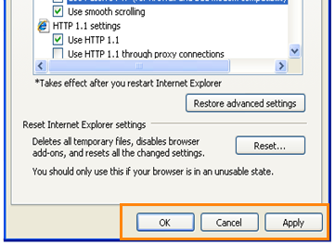
- Close all browser windows when done.
- Open a new Browser window and type the following into the address bar: ftp://app5.webinservice.com
- Click the green Go icon or press the <Enter> key.
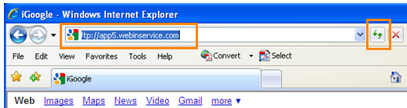
- Do one of the following:
  - If you see the following screen, proceed to step 15.
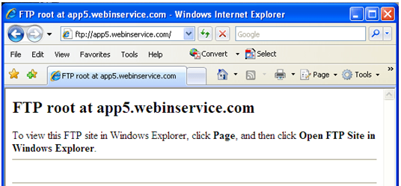
  - If you do not see this screen, proceed to step 17.
- Click the Page menu.
- Select the Open FTP Site in Windows Explorer option.
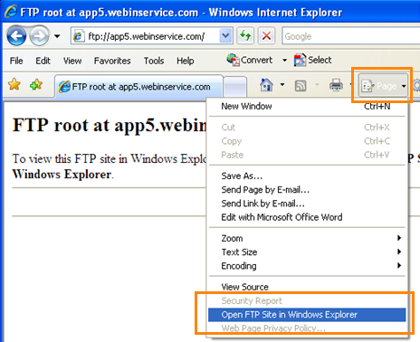
- The following displays:
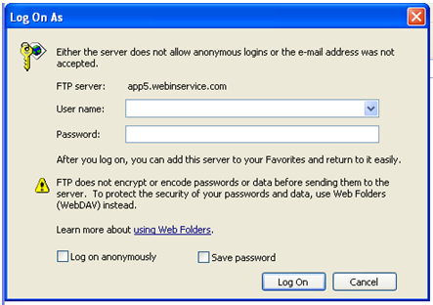
- Enter your User name and Password that have been provided.
- Click the [Log On] button when done.
- You FTP Directory displays.
